Caleb Song

Lt Col Hancock

CS 483

10 May 2024

Optimal Page Size Report

**Introduction**

In this lab the assignment was to find the optimum size of the number of frames to allocate and to find the number of frames for this process. A key requirement was to keep the page-fault rate below 10%. Four frame sizes of 512 bytes, 1 KB, 2 KB, and 4KB were chosen to test the effect of the number of frames on the number of misses and miss rate.

**Methodology**

A C program was used to simulate the effect of frames on number of misses and miss rate using a Least Recently Used stack. The program was used to output frames, number of misses, and miss rate into csv files to then be processed into graphs.

**Results**

The below graphs were created based on the outputs of the program at the four frame sizes.

512 bytes

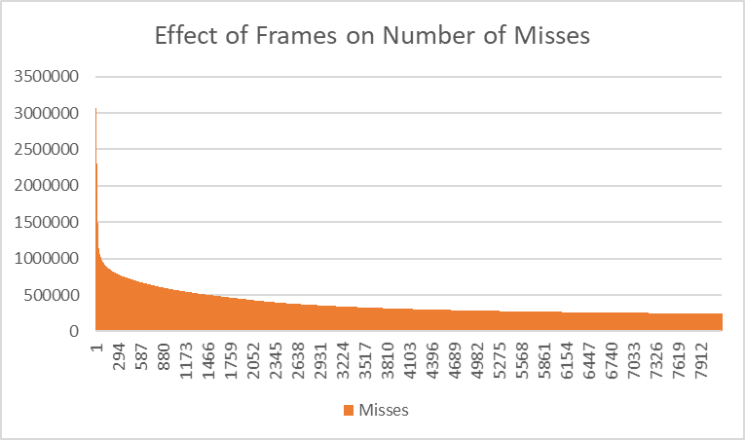

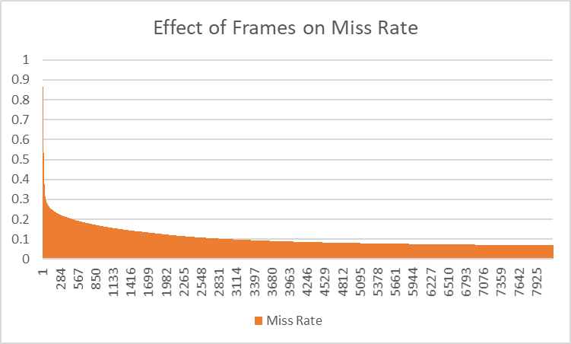

1KB

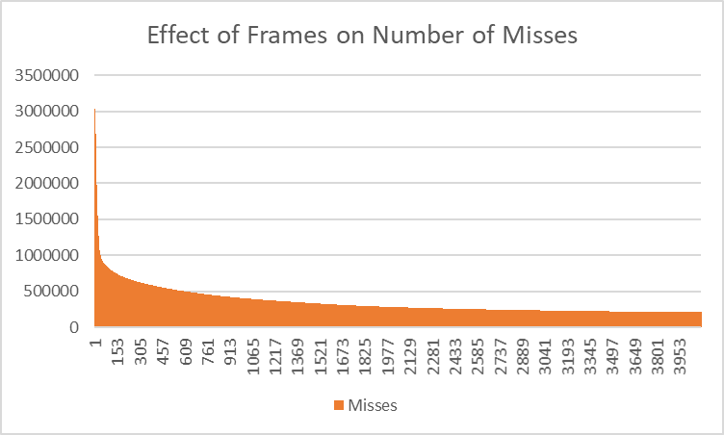

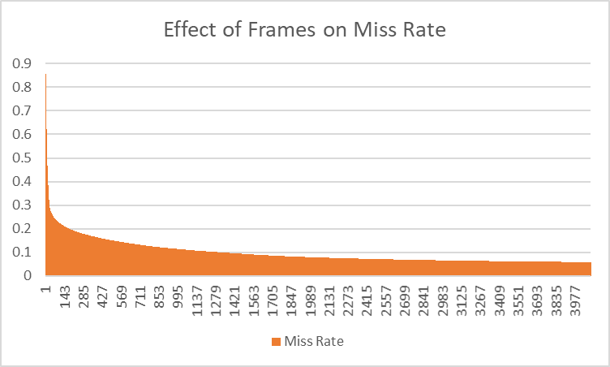

2KB

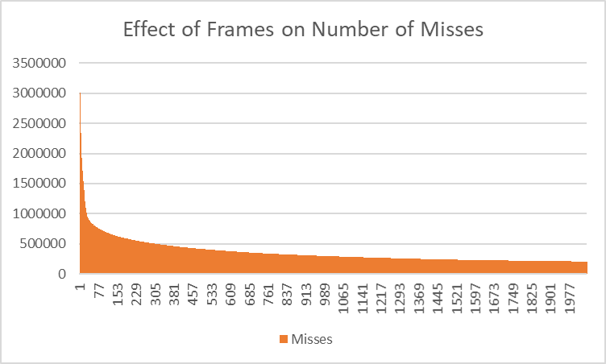

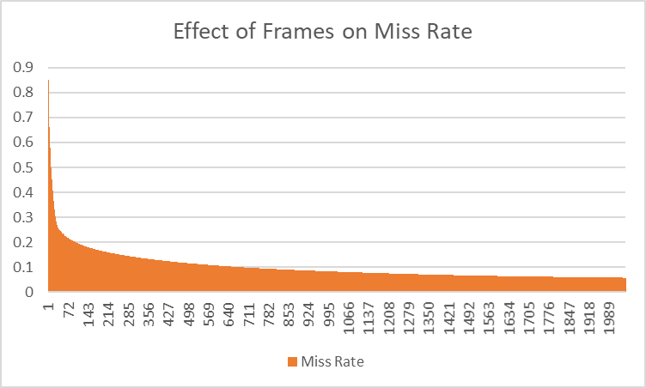

4KB

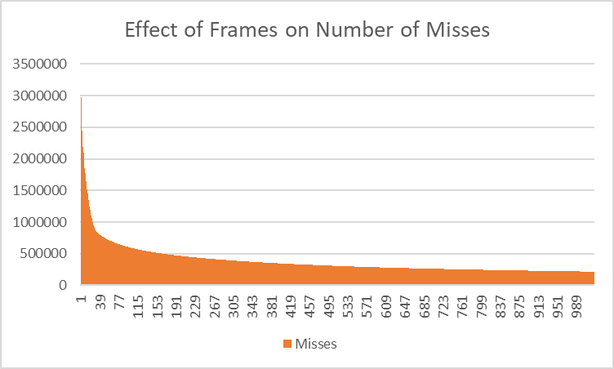

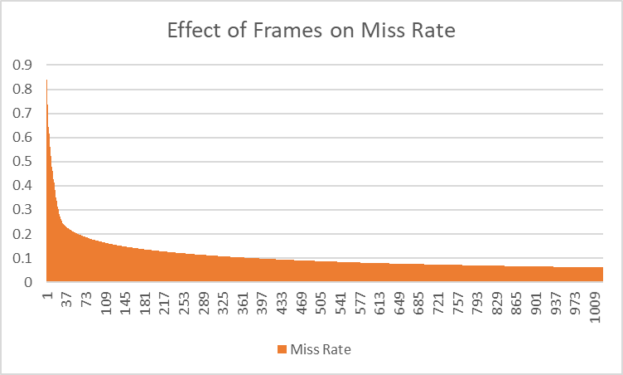

**Analysis**

Some general trends were drawn from the graphs at the four frame sizes. The first is that as the number of frames increased the number of page faults decreased because more frames available allowed for the system to keep more pages in memory. For every frame size, there was a frame number point that resulted in a significant drop off of misses. As the frame size increased this tipping point occurred at a smaller frame number than previous sizes. This is because a process needs a certain number of frames to operate without a significant amount of page faults. When the program reaches this number of frames allocated it causes a significant drop in the amount of page faults. Larger frame sizes allow for this point to be reached more rapidly as the frames can hold more data to reach this critical point. After this point however, there is a levelling off of the benefits of adding additional page frames. This diminishing returns is because the number of frames allocated reaches the critical point where it is able to handle most of the processes page requests. There is a trade-off that could occur with larger frame size as internal fragmentation can cause an inefficient use of memory if the process accesses small amounts of data.

**Recommendation**

With the key constraint of ensuring that the page-fault rate is below 10%, a recommendation based on what frame size and frame number can be made. Based on the graphs, the 4KB frame size is the most optimal frame size. It requires fewer number of frames to be allocated to achieve the critical point where the amount of page faults is significantly reduced. The recommended frame number is 380 frames as it fulfills the page-fault requirement of being below 10% at 9.99% and additional frames allocated results in diminishing returns. At 380 frames there are 353,990 misses which is not significantly reduced anymore when adding more frames than 380 (1024 frames only reduces the miss number to 215,808 misses). Overall, the recommended frame size is 4KB as it require less frame numbers to reach the critical point at a frame number of 380 as it fulfills the page-fault rate requirement with larger page numbers causing diminishing returns.